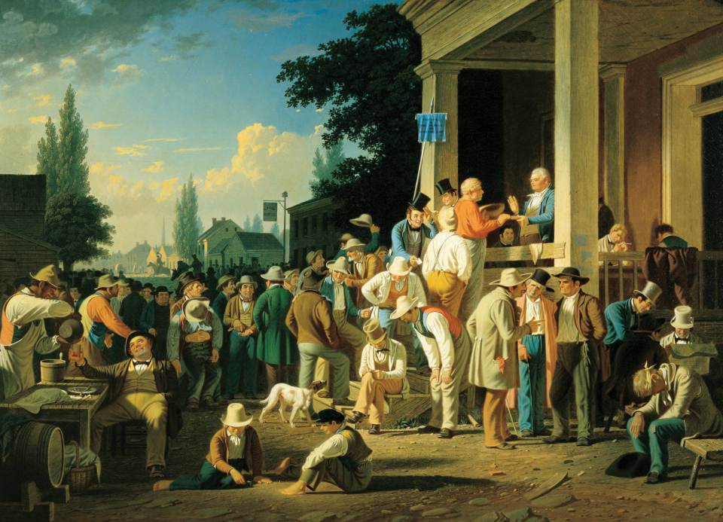
Visual A The County Election by George Caleb Bingham c. 1852
Stump Speaking (1854) by George Caleb Bingham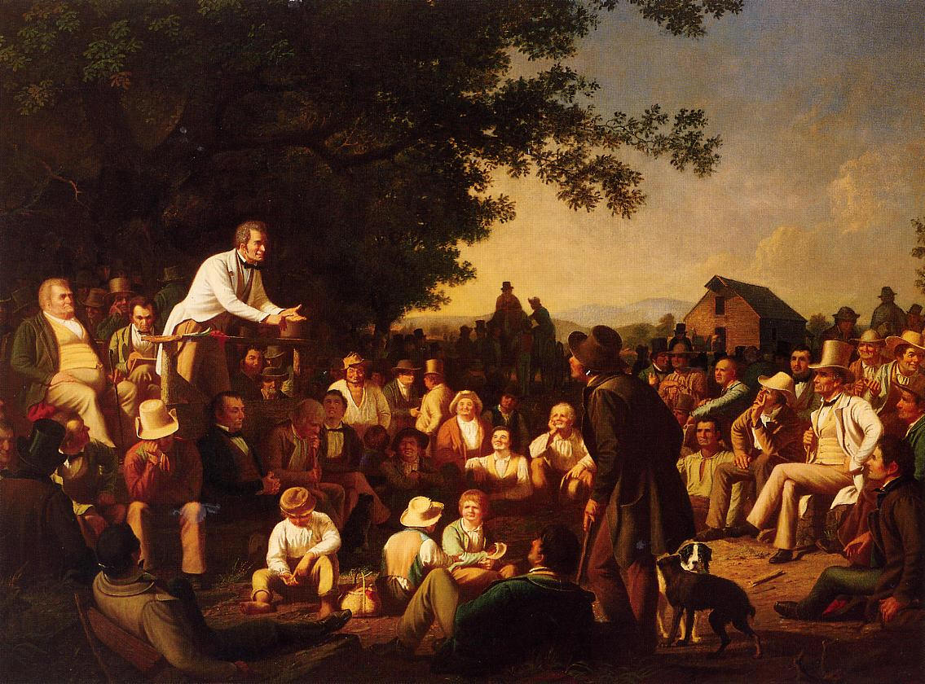
Visual B
Common Man Reading

Guiding Question: Is American better off with more democracy?

Reading 1:
The aristocracy [wealthy] of our country...continually contrive to change their party name. It was first Tory, then Federalist, then no party...then National Republican, now Whig....But by whatever name they reorganize themselves, the true democracy of the country, the producing classes, ought to be able to distinguish the enemy. Ye may know them by their fruit. Ye may know them by their deportment [treatment] toward the people. Ye may know them by their disposition to club together, and constitute societies and incorporations for the enjoyment of exclusive privileges and for countenancing [allowing] and protecting each other in their monopolies....They are those, with some honorable exceptions, who have contrived to live without labor...and must consequently live on the labor of others.
Frederick Robinson, a Democrat, 1834

Reading 2:
We believe, then in the principle of democratic republicanism, in its strongest and purest sense. We have an abiding confidence in the virtue, intelligence, and full capacity for self-government, of the great mass of our people--our industrious, honest manly, intelligent millions of freemen. We are opposed to all self-styled "wholesome restraints" on the free action of the popular opinion and will, other than those which have for their sole object the prevention of precipitate legislation.
Statement of Democratic principles

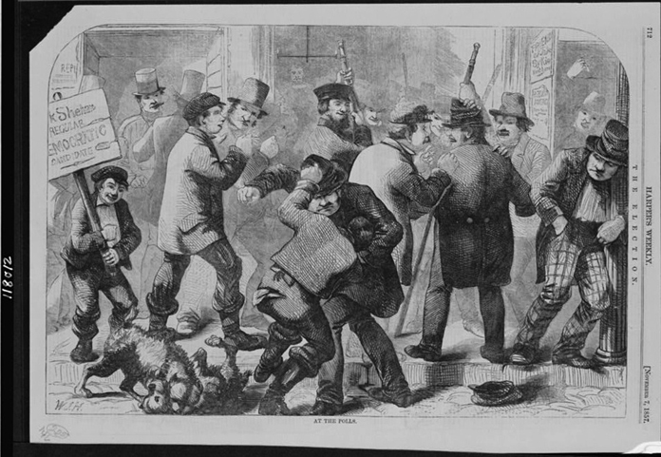

Visual C Political cartoon depicting mob violence during an election in 1857, Harpers Weekly, 1857

