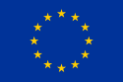

European Union in a Nutshell
"United in diversity"

What is it?

Supra-national, non-state organization consisting of 27 members states in Europe.

Evolved from economic alliances formed after WW II – is much more now.

Has experienced growth in both number (broadening) of member states AND in the power it exercises (deepening) (thus eroding state sovereignty).

Its organization and power are based on a series of treaties starting in 1991 through 12/2009.

Current areas of regulation and lawmaking: economic, immigration, citizenship of EU, currency (Euro), central bank, justice, human rights, environment

What are its goals?
“Three pillars” – 1) enhance trade and economic activity within the Union; 2) cooperation in justice and human rights, and 3) common foreign policy and European security

How is it organized? See diagram
European Commission (executive) - members from each state who swear allegiance to EU. Supervises the bureaucracy of the EU (20,000+ employees). Initiates legislation.

Council of Ministers (aka Council of the Union)(passes legislation) – consists of representatives from member states. Rotating presidency from head of government of member states. Approves addition of new members states with unanimity required.

European Parliament – elected by residents of EU. The most democratic of the EU institutions. Meets in Strasbourg, France. Approves budget and approves nominations to the European Commission. Elections every 5 years. There are “European “political parties.

European Court of Justice – Adjudicates controversies between member states and EU, and between institutions of the EU. Has favored EU power over state power.

Key dates/events
- Maastricht Treaty 1991 – established name European Union and expanded powers of EU
- Treaty of Nice 2001 – established process for adding new members. Establishes minimum requirements.
- Euro currency replaces national currency in many member states (not GB)(2002)
- 10 new countries join the EU in 2004, many from former Eastern Bloc. Proposed new EU Constitution. In 2005, France and the Netherlands reject the new constitution. Most countries were choosing to use referenda to approve the treaty.
- Because of the failure of the EU Constitution in 2005, EU members propose a new treaty, The Lisbon Treaty in 2007. Supporters of the treaty argue it will make the EU function better, while opponents claim it’s an effort to federalize Europe in disguise
- In June 2008, voters in Ireland rejected The Lisbon Treaty but then voted again and approved it. The Lisbon Treaty which amends the Maastricht Treaty, went into effect 12/2009.
Current Issues -- Can it survive?
EURO Crises; Greece!!!
UK referendum!!
Old v. new states
Rich v. poor, North v. South, West v. East
PIGS – Portugal, Ireland, Greece and Spain – economically weak states that need bailouts
European identity
Relations with US, Russia (Bear to east and major supplier of natural gas)
Agricultural interests (Common Agricultural Policy -- ag subsidies – are 35% EU budget)
Migration (internal as well) – open borders w/in EU
Status of member states allowed to “opt out” of certain treaties (so UK opted out of common currency and immigration rules)
Security and foreign policy
“Democratic deficit” - EU not very democratic
Currency
economic weakness of member states
Membership – Turkey wants in. Iceland too!

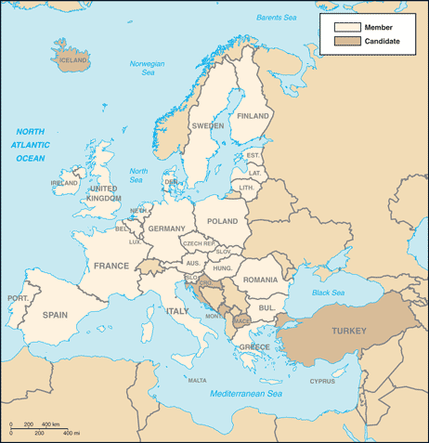
Most recent additions: Romania and Bulgaria in 2007
Population GDP (purchasing power parity)
492,387,344 (July 2010 est.)

1 | European Union | $ 15,390,000,000,000 | 2011 est.

2 | United States | $ 15,040,000,000,000 | 2011 est.

3 | China | $ 11,300,000,000,000 | 2011 est.

4 | India | $ 4,463,000,000,000 | 2011 est.

5 | Japan | $ 4,389,000,000,000 | 2011 est.

6 | Germany | $ 3,085,000,000,000 | 2011 est.

7 | Russia | $ 2,373,000,000,000 | 2011 est.

8 | Brazil | $ 2,284,000,000,000 | 2011 est.

9 | United Kingdom | $ 2,250,000,000,000 | 2011 est.

10 | France | $ 2,214,000,000,000 | 2011 est.

11 | Italy | $ 1,826,000,000,000 | 2011 est.

12 | Mexico | $ 1,657,000,000,000 | 2011 est.

