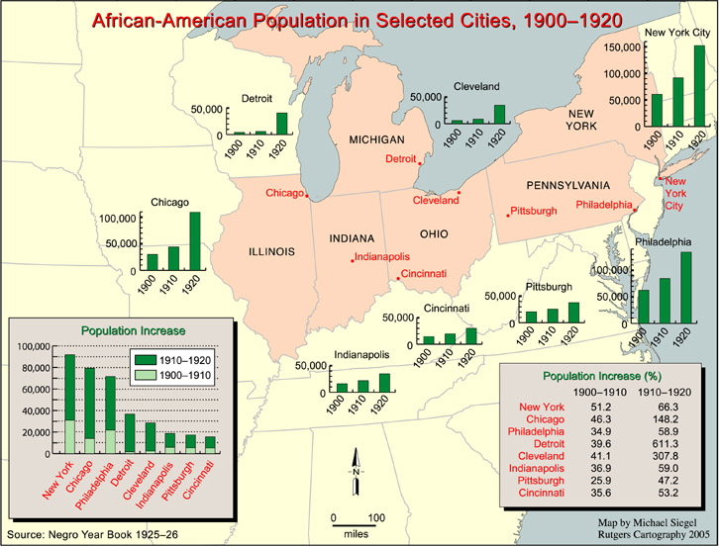

African-American Population in Selected Cities, 1900 – 1920
Source: Negro Year Book, 1925 - 26

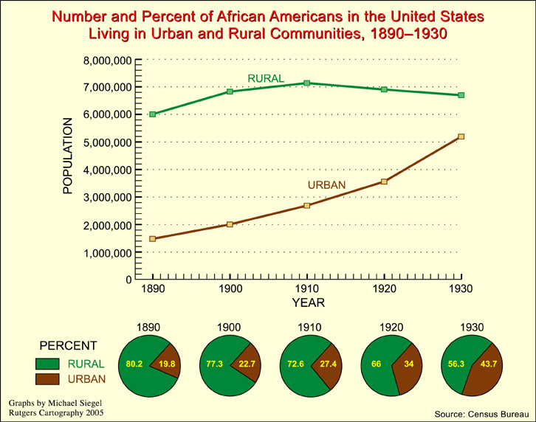

Number and Percent of African Americans in the United States Living in Urban and Rural Communities, 1890 – 1930
Source: Census Bureau

